**Trade Idea Template**

**Quantitative Analysis (Annual) – LONG**

**Quantitative Analysis (Sector Comps)**

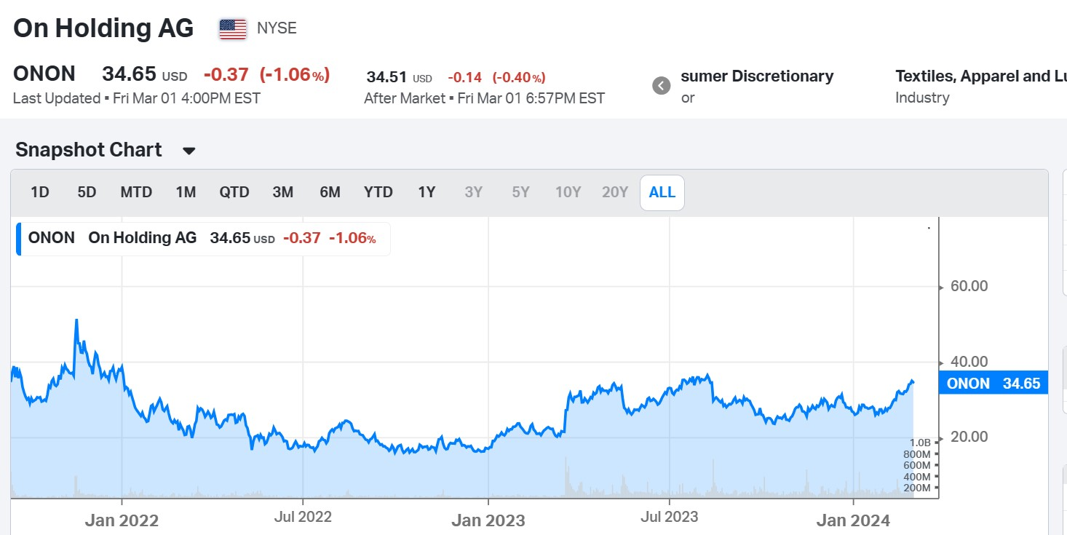



|  |
| --- |
| **Comments on Quantitative Analysis Sector Comparison**  Note: ONON hasn’t published its 10-K for FY 2023. EG1 is for the FY2023.  PE1 & PE2: ONON is identified as a significant outlier in both Period 1 & 2.  EG: Again, significantly above the sector average. The EG for FY 2025 (the actual EG2) is 37.71%, much higher than the sector average.  **Additional Sector Info:**      Strong Growth in the Industry, as indicated by the latest PMI data. (both composite and New Orders) |

|  |
| --- |
| **Comments on Annual Quantitative Analysis**    Implied Vol. 52%  **Distribution Of Return**    **Soft Target: 31.86%**  **Hard Stop Loss: 12.72%**  Business Financial Analysis:  See the Excel Attachment |
| **Comments on Business**  ON belongs to the Consumer Discretionary Sector, Textile, Appeal, and Luxury Goods Industry.  On is heading into the holiday season with confidence in the strength of the On brand and in the strength of our products  we clearly see a continued premium positioning across all the markets. And we also expect a continued high full price sell-through across all our channels and geographies. |
| **KPI’s driving Revenue and Earnings**  In Miami, On has a 15% market share on the running routes in a place like New York, it's 7%. Again, I think 2 messages. Message number one is, we're making progress. This was much, much lower at the IPO. Message number two, there's still a lot of room for growth, which is amazing.  And we are super pleased that our D2C channel has been growing a little bit stronger than our wholesale channel (Q3: With 55% growth, On's D2C business has significantly outpaced the wholesale business, which grew 43%.)  we are today that we have now 7 franchises, each contribute more than 5% to our net sales  We want to exceed CHF 3.55 billion in 2026. We will heavily focus on profitability with an 18% plus target and all of that based on a very solid gross profit margin of more than 60%, really reflecting the premiumness of the brand.  We have the clear expectation that the D2C channel will continue to outgrow wholesale. We will build on the strong e-comm platform and expanding e-com platform （beneficial to gross margin growth） |

|  |
| --- |
| **Earnings Announcements**  The higher DTC share, alongside On's premium positioning and ongoing high full-price share will further support the achievement of higher gross profit margins in the future.  The very strong gross profit margin YTD, as well as the outlook for a further increase in DTC share in the fourth quarter, gives On additional confidence to exceed its previously stated gross profit margin ambition for the full year 2023.  The increased net sales and gross profit margin outlook allow On to invest in additional brand building opportunities in the fourth quarter, while maintaining the full year outlook on adjusted EBITDA margin at 15.0%.  Based on the start of the fourth quarter, our strong Q3 results and our visibility until the end of the year, we are again increasing our net sales ambition for the full year from CHF 1.76 billion to CHF 1.79 billion, implying a full year growth rate of over 46%  increase our full year expectation to at least 59% gross margin |

|  |
| --- |
| **Catalysts excluding Earnings**  Updates on Price Target after the 12th March Earning Release  Annual Shareholder Meeting on 23 May |

**Earnings Estimate & Actual**

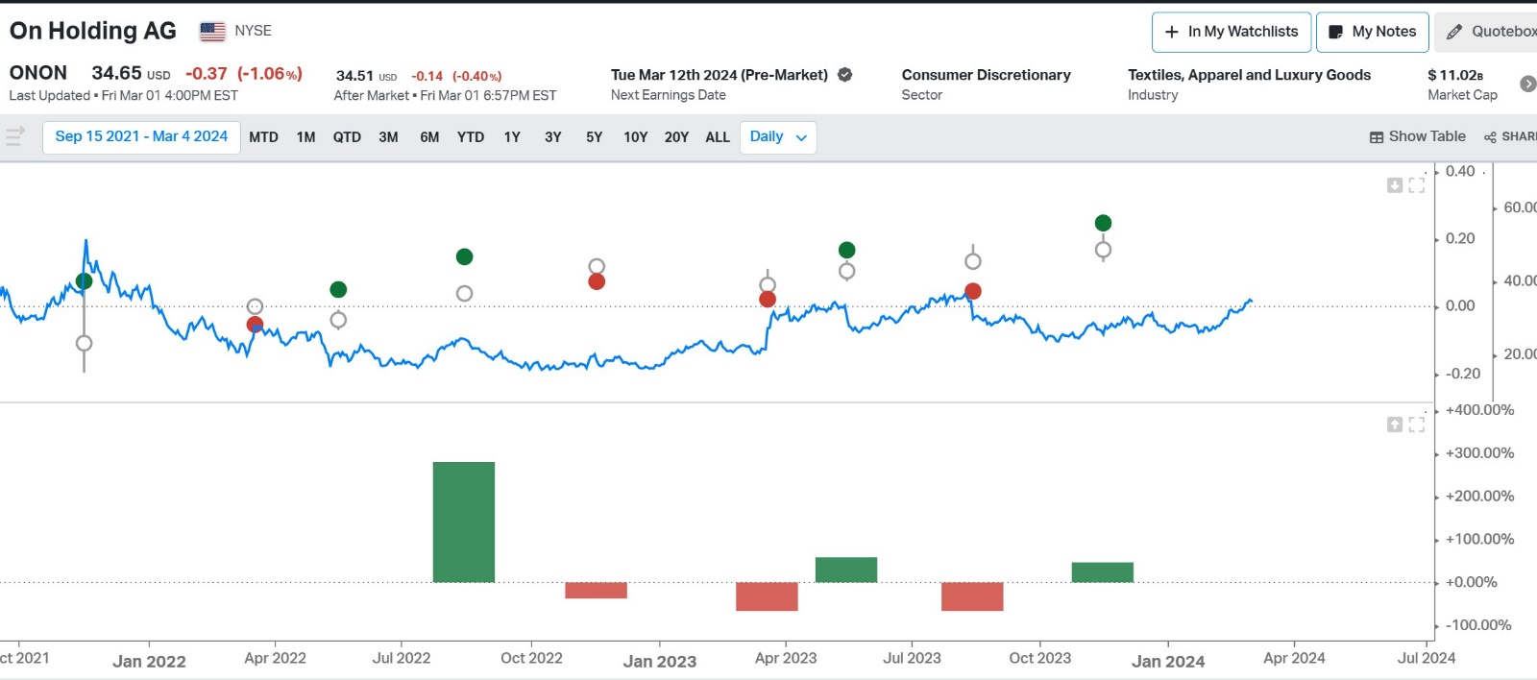

**Valuation Status**

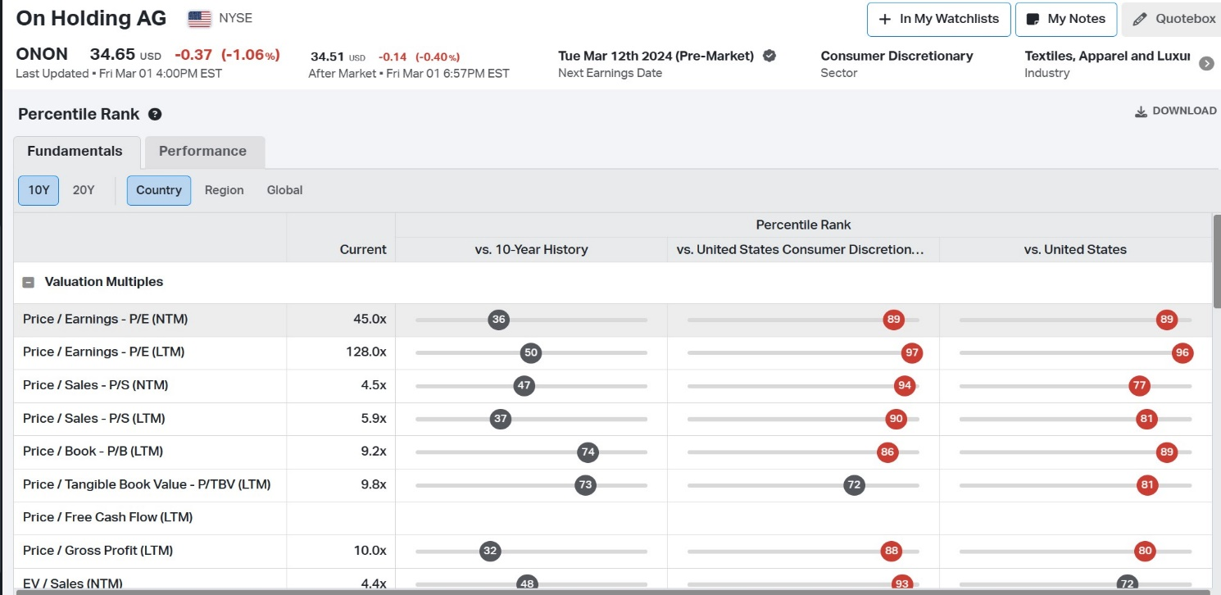

**Technical Analysis**

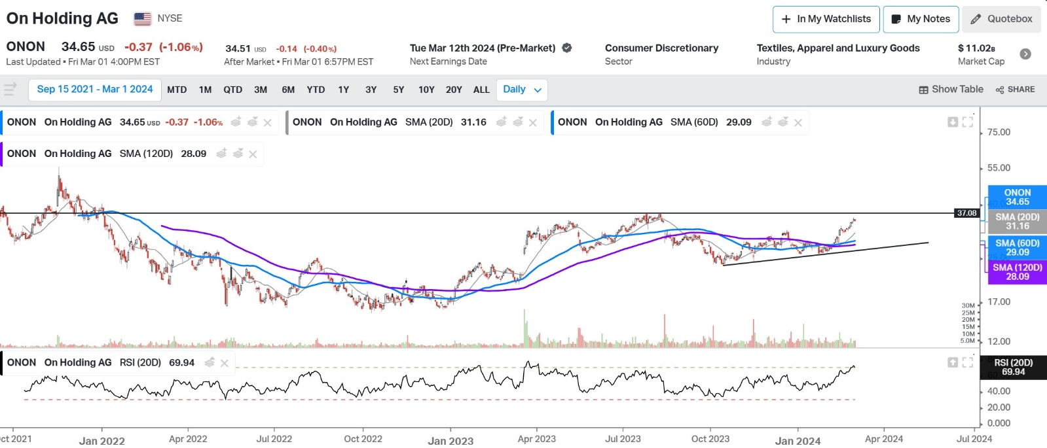

There is a potential yellow/red light situation here. The Relative Strength Index (RSI) has dropped from its peak of 72.29 to 69.94, but it remains close to overbought territory. While the 20-day Simple Moving Average (SMA) has crossed above the 60-day SMA, the stock has experienced significant growth since then and is expected to encounter strong resistance at the price of 37.08. Therefore, a short period of stock price pullback is anticipated. However, the long-term trend of the stock, as reflected by the 120-day SMA and 60-day SMA, still suggests a positive outlook. Therefore, a position might be considered once the RSI returns to its normal level or when the stock price stabilizes. (or when it breaks the resistance)

**Heed the Earnings Release!**

|  |
| --- |
| **What is your choice of trade structure and why? Include time horizon for trade.**  Depend on the result of earnings release and the qualitative statements. |