**Trade Idea Template**

**Quantitative Analysis (Annual) - LONG**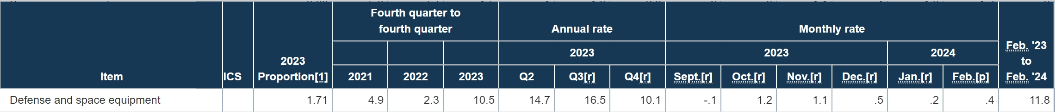

|  |
| --- |
| **Comments on Quantitative Analysis Sector Comparison**  YOY Growth of 7.3% and 11.8% in two related industries, with positive MOM growth in two consecutive months in 2024.    Above Sector Average Growth in FY2024 and FY2025, after excluding sector outlier (BA).  Approximate Growth in 2024 and 2025  **Comments on Qualitative Analysis Sector Comparison**  “For the first time since the 1960s, the defining problem isn’t inadequate demand, but inadequate supply. Output is now determined by production limits, not market needs.”  “For commercial aircraft, with airlines and other customers eagerly awaiting jets they can’t get, and travel demand remaining solid, it’ll be at least 2-to-3 years before we need to worry about the usual market indicators.”  [2024 Forecast - Aerospace Manufacturing and Design](https://www.aerospacemanufacturinganddesign.com/article/2024-forecast/) |

|  |
| --- |
| **Comments on Annual Quantitative Analysis**  **Sales:**  FTG: (approximately 60% -70% of sales, 44.36% sales growth in Q1)  Driven by 1. Acquisition of Wensor (12%, continues to grow above expectation)  2. High teens organic sales growth in both “Aftermarket Replacement Parts” & “repair and overhaul parts and services product”. (Demand Driven, beneficial to Gross Margin according to FY23)  ETG: (12% sales growth in Q1)  Driven by 1. Acquisition in FY2023  2. Double-Digit Growth in Aerospace Products (beneficial to Gross Margin, according to FY23)  Offset by 1. Other electronics, medical and space products (No major effect on Margins)  **Margin:**  Gross Profit Margin decreased from 39.07% to 38.86%, due to decrease in net sales of defense products in FY 2023 in the ETG group. (solved) FTC group 1.7% improvement in Gross Margin  Gross Profit Margin in Q1 2024 lower than Q1 2023 due to expected acquisition Wencor (True Margin- 23.5%, compared to 22.2% in Q1 FY23)  --Expect Operating Margin before acquisition to be higher than FY 2022 level (23%), 21%-22% after.  --Expect Margins, before and after amortization, to improve in the quarters ahead  **Net Income:**  Expect 15%-20% Net Income Growth in FY2024, 10yr CAGR has been 14.29%  (No Guidance)    **Analyst Estimate:** |
| **Comments on Business**  HEICO Corporation, through its subsidiaries, designs, manufactures and sells aerospace, defense, and electronic-related products and services in the United States and internationally. |
| **KPI’s driving Revenue and Earnings**  Goal: To grow net income by 15% to 20% annually compounded  Cash Generation is Paramount (with a 46% increase in operating cash flow in Q1 YOY)  Net Sales to EBITDA 2.79x, from 3.04x in the last quarter  PMA Parts Expectation: 400 parts a year (in line with 2022) + 150 parts (from the acquisition of Wencor) |
|  |

|  |
| --- |
| **Earnings Announcements**  May 23rd, 2024 |

|  |
| --- |
| **Catalysts excluding Earnings**  Industrial Production and Capacity Utilization - Federal Reserve, Mid-April  Semi-Annual Dividend on 29th June  Boeing’s mess in recent days  Boeing’s Earnings Announcement – 24th April  Axon’s Earnings Announcement – 8th May |

**Technical Analysis**

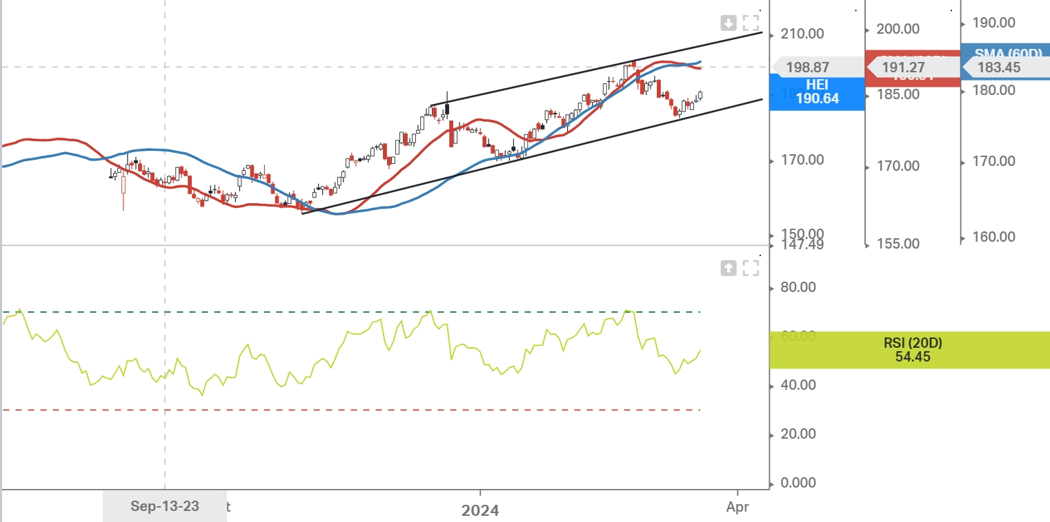

Green Light. Though 60 SMA crossed 20 SMA, HEI is still in the upward channel, with healthy RSI.

|  |
| --- |
| Implied Volatility  24% |