**Investment Idea Generation Sheet**

* **Sector Level Analysis**

Step 1:

Investment Logic

& Economic Sensitivity of the Industry

(Certainty, Growth Potential, Diversification, Defensiveness)

(Cyclical, Defensive)

Defensive (not entirely defensive)

Diversification

Step 2:

Sector-Industry

& Subgroup within the Industry

-Healthcare

-Healthcare Services (& Healthcare Equipment, Biopharmaceuticals)

-Miscellaneous Services

-Veterinary Products and Services

Step 3:

Industry Life Cycle

& CAGR

(Introduction, Growth, Shake Out & Maturity, Decline)

Shake Out

Step 4:

Competition Within the Industry

& Market Share Dynamic

(Monopoly, Uni-multipolarity, Oligopoly, Perfectly Competitive)

Uni-Multipolarity (Market Leader)

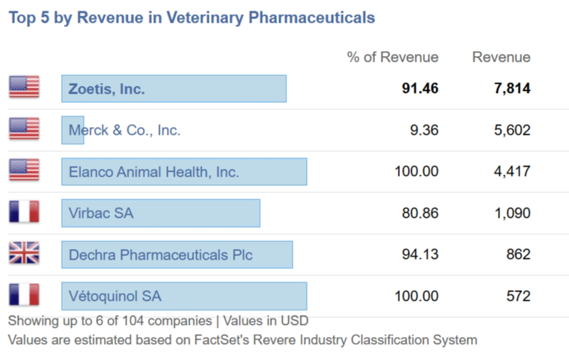

Step 5:  
Reasons Why You Would Not Invest in the Industry

Not Defensive Enough in times of Economics Downturn, with 5 yr unlevered beta of 0.88

Healthcare has been underperforming the market in recent months

* **Stock Filtering**

Step 1:

Forward P/E Comparison

|  |  |  |  |  |  |
| --- | --- | --- | --- | --- | --- |
|  |  |  | **P/E (x)** |  |  |
| **Company** | **Fiscal** |  |  |  |  |
| **Name** | **Period** | **EV (M)** | **Actual** | **FY1** | **FY2** |
| Zoetis A | 03/31/2024 | 81,572.0 | 32.37x | 29.07x | 26.26x |
| IDEXX Laboratories Inc | 03/31/2024 | 42,571.2 | 48.74x | 45.45x | 39.85x |
| Elanco Animal Health | 03/31/2024 | 14,149.5 | - | 18.06x | 15.90x |
| Merck & Co | 03/31/2024 | 358,336.3 | 143.93x | 14.97x | 13.05x |
| Phibro Animal Health A | 03/31/2024 | 1,134.1 | 55.74x | 16.17x | 13.08x |
| **Average** |  |  | **70.19x** | **24.75x** | **21.63x** |
| **Median** |  |  | **52.24x** | **18.06x** | **15.90x** |

Step 2:

Revenue Growth

& EPS Growth Forecast

& Operating Cash Flow& FCF

& Asset Turnover & Profit Margin & ROA

|  |  |  |  |  |  |
| --- | --- | --- | --- | --- | --- |
| **Company** |  | **Sales** | **Sales** | **% Change** | **% Change** |
| **Name** | **Sales** | **FY1** | **FY2** | **FY1** | **FY2** |
| Zoetis A | 8,734.0 | 9,158.3 | 9,772.9 | 4.86% | 6.71% |
| IDEXX Laboratories Inc | 3,724.9 | 3,955.7 | 4,356.2 | 6.20% | 10.13% |
| Elanco Animal Health | 4,365.0 | 4,491.4 | 4,685.7 | 2.89% | 4.33% |
| Merck & Co | 61,093.0 | 64,119.6 | 68,771.8 | 4.95% | 7.26% |
| Phibro Animal Health A | 999.6 | 1,002.6 | 1,165.9 | 0.30% | 16.29% |

|  |  |  |  |  |
| --- | --- | --- | --- | --- |
|  |  |  |  | **Total** |
| **Company** |  | **ROA** | **ROA** | **Asset** |
| **Name** | **ROA (%)** | **FY1 (%)** | **FY2 (%)** | **Turnover (x)** |
| Zoetis A | 17.0% | 17.4% | 18.0% | 0.62x |
| IDEXX Laboratories Inc | 28.1% | 27.1% | 27.9% | 1.21x |
| Elanco Animal Health | -8.7% | 3.2% | 3.6% | 0.29x |
| Merck & Co | 2.2% | 18.8% | 19.1% | 0.57x |
| Phibro Animal Health A | 1.4% | - | - | 1.03x |
| Average | 8.0% | 16.6% | 17.2% | 0.74x |
| Median | 2.2% | 18.1% | 18.6% | 0.62x |

|  |  |  |  |  |  |  |
| --- | --- | --- | --- | --- | --- | --- |
|  | **Gross Margin (%)** | | **EBIT Margin (%)** | | **Net Margin (%)** | |
| **Company** |  |  |  |  |  |  |
| **Name** | **Actual** | **NTM** | **Actual** | **NTM** | **Actual** | **NTM** |
| Zoetis A | 68.3% | 70.4% | 36.0% | 38.8% | 27.4% | 29.0% |
| IDEXX Laboratories Inc | 60.1% | 60.6% | 29.9% | 30.8% | 23.3% | 23.6% |
| Elanco Animal Health | 42.7% | 56.2% | 5.5% | 19.4% | -29.8% | 10.7% |
| Merck & Co | 71.6% | 80.1% | 8.2% | 41.8% | 3.8% | 35.3% |
| Phibro Animal Health A | 30.2% | - | 5.9% | 8.9% | 1.3% | 4.1% |
| Average | 54.6% | 66.8% | 17.1% | 27.9% | 5.2% | 20.5% |
| Median | 60.1% | 65.5% | 8.2% | 30.8% | 3.8% | 23.6% |

Step 3:

Decision-Making Comments

PE is trading at a premium to the sector in both FY1 and FY2

ZTS saw high gross & operating margins in both FY0 and FY1, well above sector average level

Its ROA ratio is also expected to increase continuously at a stable pace

Sales growth falls within the middle range, while being higher than direct competitor ELAN

* **Company Level Analysis**

Step 1:

Business Model

**-Sales Distribution**

Americas: 65.7% Veterinary Products: 95.86%

Asia/Pacific: 16.5% Animal Feed Manufacturing: 4.14%

Europe: 15.7%

Africa/Middle East: 2.1%

**-Understanding Each Module** (growth, margin, qualitative statement)

Companion Animal Portfolio grew 20%

Livestock declined 1%

SIMPARICA TRIO +61%, $205m (dermatology product)

LIBRLA & SOLENIA +189%/100%, $40m/$17m (OA Pain, “next 1 billion franchise)

Step 2:

Quantitative Assessment of Financial Report

**-Growth**

Revenue Growth:

Q1 9.5%, 5.74% for FY23

FCF Growth:

Q1 39.57%, 22.25% for FY23

Net Income Growth:

Q1 8.51%, 10.88% for FY23

**-Efficiency**

Asset Turnover:

Q1 0.62, 0.58 for FY23, 0.59 for Q1 23

**-Profitability**

Gross/ Operating Margin:

68.95%, 68.28% for FY23, 68.75% for Q1 23

36.58%, 35.92% for FY23, 36.40% for Q1 23

**-Financial Health**

Long-term Debt to Equity Ratio: (<2.0)

1.33

Interest Coverage Ratio: (pattern)

11.38, highest in 3 years

Current & Quick Ratio:

-KPIs

Vet clinic visits down 1.5%

(growth in the therapeutic visits, while wellness visits drove the decline)

Spending per visit up 6%

Revenue in the clinic up 4.5%

Of the 12% operational revenue growth, 7% is from price with 5% from volume.

80% reorder rate

-Notable Comments from Transcript

It also highlights the continued rise and resilience of the animal health industry

We remain confident that OA pains could be our next $1B franchise, because we are meeting the needs of an underserved market

Looking ahead to the remainder of 2024, our increased operational guidance reflects the resilience of the animal health market and the execution of our strategic growth priorities

Step 3:

Management of the Company

-CEO Educational Background & Business Experience:

-Proportion of Independent Director (Av. 85%)

-CEO Salary Structure (linked to the performance of company or not)

-Equity Structure

Step 5:

Valuation of the Company (NTM)

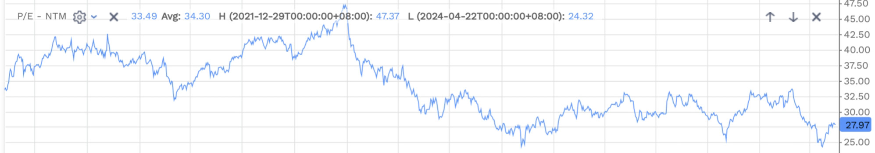

Step 6:

Volatility of the Stock

-Volatility

28.45%

-Beta

0.88

-Implied Volatility

28%

-Correlation with Existing Ideas

LOW (none above 0.5)

Step 7:

EPS NTM & Price Target Revision (pattern)



Step 8:

Investment Risk (read reports with neutral or underperform ratings)

Safety concern over LIBRELA (when being reported in April, the share dropped 8%)

The management said this is a rare incidence and the drug has been approved in the market for 3 years