**Trade Idea Template**

**Quantitative Analysis (Annual) - LONG**





|  |
| --- |
| **Comments on Quantitative Analysis Sector Comparison**  Sector Growth trends lower in the next 2 years  5.98% CAGR between 2022-2030, from Renub  DE is well below the average growth in the period, with negative growth in 2024 and low single-digit growth in 2025  PEs in two periods are well below average  PMI suggests low growth in this sector since late 2023 |

|  |
| --- |
| **Comments on Annual Quantitative Analysis**  5-year sale CAGR 11.8%. However, in Q1 it shrank 3.69%, with a 2024 outlook of -20% in Production & Precision Ag, -10%-15% in Small Ag and Turf, -5-10% in Construction and Forestry.  Operating Margin has been increasing in recent 5 years, from 10.99% to 25.42%. It is now 18.51% in Q1. with a 2024 outlook of 22% in Production & Precision Ag, 15-16% in Small Ag and Turf, and 17-18% in Construction and Forestry.  Financial Services is the only segment of the industry expecting growth in 2024, however, only constitutes 8% of the total revenue.    Despite the plummet in Earnings Growth, the valuation, which is positively correlated with the next 1-2 year’s Revenue growth, is still close to the 3-year average.    Implied Volatility  26% |
| **Comments on Business**  Deere & Company engages in the manufacture and distribution of various equipment worldwide. The company operates through four segments: Production and Precision Agriculture, Small Agriculture and Turf, Construction and Forestry, and Financial Services. |
| **KPI’s driving Revenue and Earnings**      **·**Agricultural fundamentals are expected to moderate in 2024 due to lower commodity prices and elevated interest rates, offset by resilient farm balance sheets and lower input costs. （2023 10-K）  **Major Commodity Prices**      The reduction in major commodity prices harms farmers’ income, which is strongly correlated to the sales of DE. Note that prices have rebounded recently. May short the stock when the downward trend continues.    expect slightly stronger sales through the back half of the year |

|  |
| --- |
| **Earnings Announcements**  Deere (DE) reported fiscal Q1 earnings Thursday of $6.23 per diluted share, down from $6.55 a year earlier.  Analysts polled by Capital IQ expected $5.21.  Net sales for the quarter ended Jan. 28 were $12.19 billion compared with $12.65 billion a year earlier.  Analysts polled by Capital IQ expected $10.33 billion.  **Next Earnings Day**  May 16th, 2024 |

|  |
| --- |
| **Catalysts excluding Earnings**    Downward revision of the EPS and average price target.  CNHI’s Mid-Term Earnings Release: May 3rd 2024  CAT’s Earnings Release: Apr 26th 2024 |

<Insert choice of Technical’s and Price Action charts for timing and check short interest for path of least resistance.>

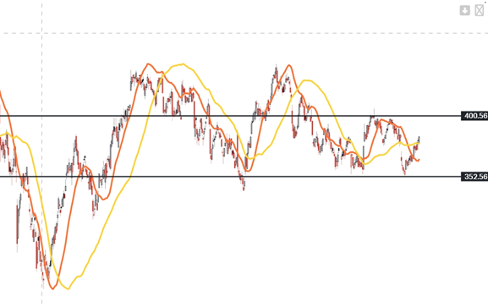

See if the stock would break the resistance. If it fails and starts to go down, then it would be a green light.

20/60 SMA does suggest that the stock would trend downward. (RSI is rising at above-50 level, though.



  
  
  