VITL
FY 2023 10-K
Business Overview
Vital Farm is is an ethically minded food company that is disrupting the U.S. food system, which has developed a framework that challenges the norms of factory food model and allows them to bring high-quality products from their network of 300+ family farms (the foundation of its resilient and reliable supply chain) to national audience. The framework allowed them to become the nation’s leading pasture-raised eggs and the second-largest US egg brand by retail dollar sales. Ethics are exemplified by focus on animal welfare and sustainable farming practices, including regenerative agricultural practices. They believe happy hens produce high-quality eggs. Certified B Corporation. Conscious Capitalism.
We believe our relationships with family farms and the efficiency of our supply chain provide us with a competitive advantage in the consumer packaged goods industry, in which achieving reliable supply at a national scale can be challenging.
Opened Egg Central Station in 2017, which is centrally located within the network of family farms (doubled in capacity in 2022). This is a shell egg processing facility. They believe owning and operating this important element of our supply chain is a key differentiator and provides us with a competitive advantage, which we intend to continue to leverage to grow both our net revenue and gross margin. We are currently in the process of exploring potential sites for an additional egg packing facility. Today, Egg Central Station is capable of packing six million eggs per day and has achieved an SQF Excellent rating, the highest level of such certification from the GFSI.
Our mission is to bring ethical food to the table. We carry out our purpose and mission by partnering with family farms that operate within our strictly defined set of ethical farming practices. In our view, the factory farming system has been consistently misguided, focused on producing products at lowest cost rather than driving long-term and sustainable benefits for all stakeholders. We believe our consumers connect with Vital Farms because they love our products, relate to our values and trust our practices.

Industry Overview
We believe increased demand for natural food and a willingness to pay a premium for brands focused on transparency, sustainability and ethical values will continue to be a catalyst for our growth.
According to SPINS:
US shell egg market accounted for approximately $9.0 billion in retail sales in 2023,
Grew at CAGR of 10.3% from 2020-2023
U.S. pasture-raised retail egg market accounted for approximately $531.0 million in retail sales in 2023,
Grew at CAGR of 26.6% from 2020-2023
US specialty egg (including pasture-raised, free-range and cage-free) market accounted for approximately $1.8 billion in retail sales in 2023
Grew at CAGR of 11.2% from 2020-2023
U.S. butter market accounted for approximately $4.8 billion in retail sales in 2023
Grew at a CAGR of 5.3% from 2020-2023
Household Penetration: 7.5%
Low compared to shell egg category of approximately 96.5%

Growth Strategy
- To drive higher product velocities and increase average SKU count per retail partner with existing customers
- Expand product new with confirmed demand for their ethically produced products
- Strengthen brand awareness & penetration through education & social media

Competition
Named Competitors: Cal-Maine, Ornua Co-operative

Seasonality
Demand for shell eggs and butter fluctuates in response to seasonal factors. Demand tends to increase with the start of the school year, is highest prior to holiday periods, particularly Thanksgiving, Christmas and Easter, and is lowest during the summer months.

Risk Factors
- Decline of commodity shell egg prices relative to the prices of their shell eggs, could adversely affect their business.
- Fluctuation in prices of feed grains could negatively impact their business
- Outbreak of agricultural diseases, including avian influenza.
- Could be adversely affected by a change in consumer preferences, perception and spending habits in the natural food industry generally and with respect to animal-based products in particular.
NOTES:
I thought regulation & concerns against the idea of “pasture-raised” would be very challenging (no strict definition and customers might doubt if hens are really pasture-raised) for a company like Vital Farms, which relies heavily on ethics. In turned out that lawsuits did happen, but now they’ve opened access to cameras to the farms where customers purchase eggs from (publicly available on their website), a huge step towards visibility and once again raised the standards in the industry. So I think concerns regarding safety & ethics could be left aside for now.

Investor Day Presentation
LT Target:
$1 bn in Rev. by FY 2027
35% Gross Margin
12% to 14% Adj. EBITDA
+ 8000 new stores, 250 new family farms, 20 million new households (customer)
Legislation:
10 states have passed laws to remove Caged Eggs, with 3 states in process of legislation.
Target Customer:
10.5 mn current households
34 mn households as core consumers in the market (up by 20 mn since VITL’s IPO in 2020)
72 mn households are buying premium eggs
131 mn total U.S. households
Goal is to triple the number of current households
Loyalty:
36% of customers would leave the stores with no eggs if they don’t find Vital Farms’ products
(survey, n=2000)
Growth:
Increasing Total Distribution Points in the FOOD Channel drives most significant Rev. growth
Gaining momentum in Mass Channel, remained under-penetrated to peers
Could still expand TDP in the natural channel
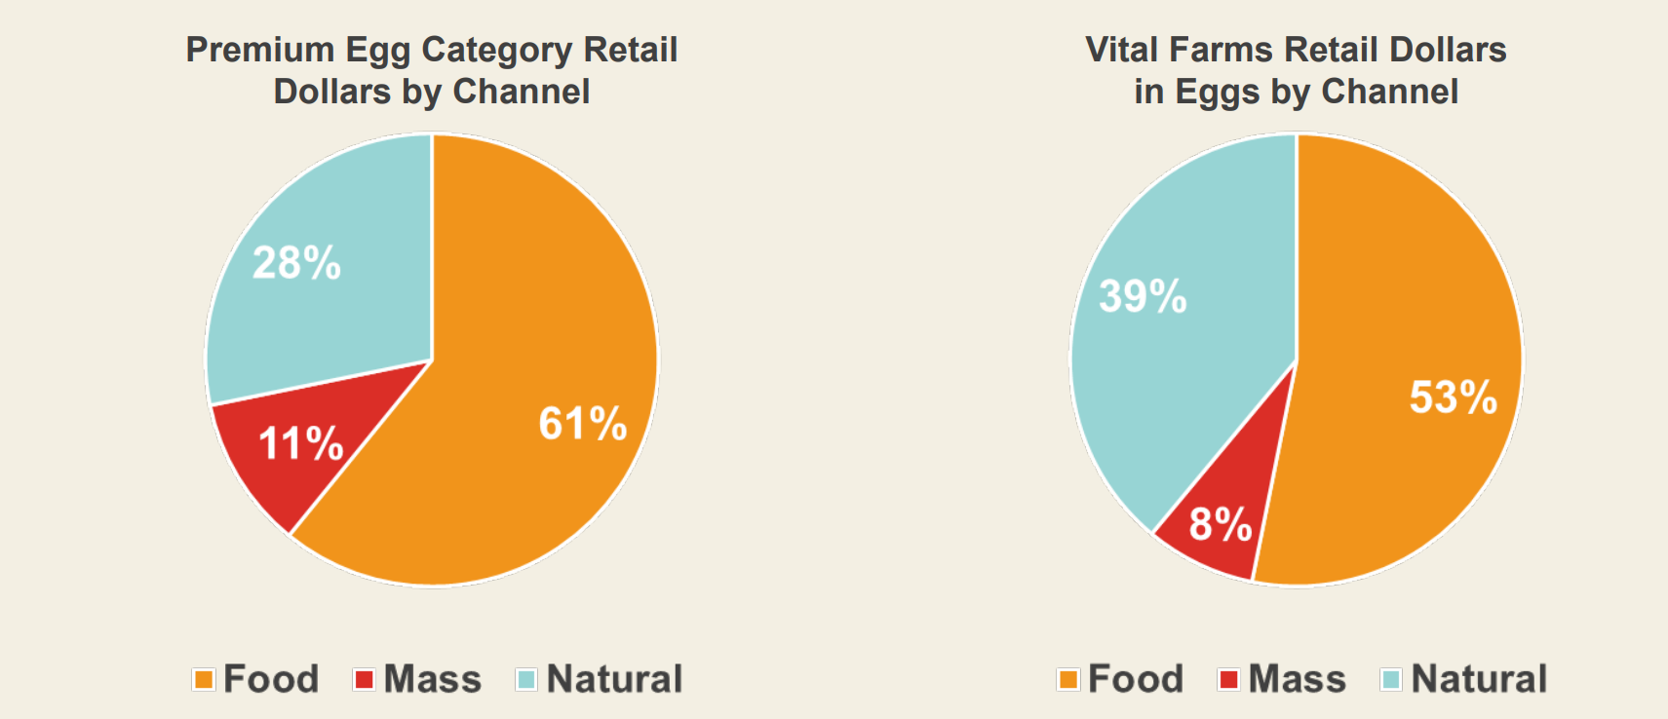
SUM UP TO 3 MAIN GROWTH DRIVERS:
- 20 mn new households
- 8000 new stores
- Increase average number of items with current retailers
Key Metrics:
Potential Distribution Points, Average Number of Items in each channel
FOOD CHANNEL: current. Potential TDPs 450, Average Number of Items 5.2 (largest driver)
MASS CHANNEL: current. Potential TDPs 400, Average Number of Items 5.1
Natural CHANNEL: current. Potential TDPs 550, Average Number of Items 6.0.

Q2 FY 2024 Conference Call
- will be stepping up brand marketing investment in the back half of the year, driving our message to consumers as we push to reach 30 million households by 2027
- 300 bps tailwinds of Rev. growth this quarter, due to avian influenza last year
- Gross Margin benefited from sales growth, productivity gains, selective pricing, efficient supply chain execution, and a more benign commodity cost environment
- On yoy basis, Natural Channel TDP up by 19% to 453.
Food Channel TDP up by 17% to 215
- Now work with 350 family farms, up from 300+ at the beginning of the year
- New Egg Central Station in Seymour, Indiana. Break ground in 2025 and begin operation in 2027
- Expect to have ample room to expand once pass the 2027 target
- Update on BUTTER: Relaunched butter line in April, chose supplier in Ireland.
- Our overall butter business is down so far this year as we're lapping the discontinuation of our tub butter SKU late last year. However, we expect a return to growth in the second half of the year.
- Egg Central Station capacity grown from 700 mn to 800 mn. The new one expects 350 mn capacity to reach 1 bn rev.

- Net revenue growth 38.5%, with 35.8 volume growth & modest price/mix benefit
-Raised Guidance: now expect 590 mn sales (=25% growth)
from 575 mn sales (=22% growth)
now expect Adjusted EBITDA 75 mn (=55% growth)
from 70 mn (=45% growth)
- Our updated 2024 guidance reflects a strong performance in the second quarter and good visibility on demand and commodity prices for the second half of the year.
- Expect net revenue to be evenly split between H1 and H2
- Lower Gross Margin in the H2, above 35%
- Expect higher Adjusted EBITDA margin in the H1 than H2 (reflect marketing investment)
- With the construction of the Seymour facility, we anticipate elevated CapEx spending for the next few years with the bulk of the spending in 2025 and 2026. We intend to fund the Seymour facility and our other projects with existing cash and operating cash flow, and we project that every dollar of CapEx investment in the new facility will generate more than $5 of annual revenue capacity, which we consider a very strong return.
- Marketing Investment as % of Rev. in the H2: a bit similar to last year, but with even larger magnitude.
Expect 5%-6% marketing expense as % of Rev.
- we're very intentional and planned very well in advance to make sure that we don't face the common constraints on growth here at a fast growing company.
- we believe that we will have that facility up and running by the end of 2026 or the beginning of 2027 (referring to the Egg Central Stattion), and that that will be well timed with hitting our capacity in Springfield and needing to add capacity.
- Expect elevated Capex in 2025, 2026 due to new Egg Central Station. However enough Cash on Balance Sheet to finance it. ($153 mn)
- With Q3, expect ECS capacity to regress to the mean, meaning lower operational efficiency in Q3 & Q4 than H1. (embedding prudence)
- in CEO’s estimation, Q2 was probably the biggest year-over-year benefit and fall-off commodity costs. So the margin benefit that we get from that probably peaked in Q2. (with visibility into Q3 and little in Q4)
+ butter business starting to grow, maintenance needed, pressure on margin
Therefore expect H2 to be about LT guidance (35% gross margin)
- About The MOAT:
1. Transparency and Education provided to customers, enable VITL to sell products at premium price with high volume.
2. Best network with farmers in this country. Education + Resources + Time. Farmers know what u did to them when times are tough.
TO SUM UP: better at growing our supply in line with our business plans and attracting and retaining great farmers
- Historically, egg price does not affect much about the gross margin and growth trajectory of the business

TD Cowen 8th Annual Future of the Consumer Conference June 04, 2024
- Don’t adjust prices up or down depending on supply-demand imbalances => to consolidate the brand image
- Core Customers: Higher Income, Higher Education, Higher Ethics.
Some ppl buy cuz they wanna support the brand (50% out of the core customers)
- Right now, Vital Farms are in 24000 stores, with 8000 more that sell specialty eggs (growing distribution opportunities)
- Biggest Growing Opportunities:
More SKUs on existing shelves.
Food Channel: 2.8 SKUs
Natural Channel: 5 SKUs (highest would be 8-9)
- About the New ECS:
Each dollar invested in the facility => $5 dollar of revenue capacity out of it
Construction Costs above 17 mn
- How Farmers Network Grown:
1. farmers apply to become a Vital Farm farmer
2. 12-18 months application process, to build barns, prepare land, get chicken
Training of farmers within the same period
(mostly, farmers join because friends & family invitation, a solid indication that Vital Farms treat farmers fairly)
3. Farmer Support Team pays a monthly visit to each farm once joined
- More resilient to Avian Influenza: any one farm takes up less than 0,5% of total supply, farms are well-dispersed.
- Other Growth Opportunities?
Under internal discussions, no concrete answer here. Now, focused on 20%+ stable growth & maintaining double-digit Adjusted EBITDA margin.

“fluctuate based on the cost and supply of commodities, including corn, soybean meal and other feed ingredients.” Impact margin !!!

